2021 Reserve Study

Introduction
A reserve study is a state mandated long-term capital budget planning tool which identifies the current status of the reserve fund and a stable and equitable funding plan to offset ongoing deterioration, resulting in sufficient funds when those anticipated major common area expenditures actually occur. The reserve study consists of two parts: the physical analysis and the financial analysis. The physical analysis consists of a list of capital items, their useful life, remaining life, and current replacement cost. The financial analysis is a projection of available funds and future replacement costs at the end of life of each asset. Assumptions in the financial analysis are the average long-term interest rate and the average inflation rate.
Although a Reserve Study is required by law to be updated annually and more completely every 3 years, there is no required level of Replacement Reserves. The most conservative level of funding is called “fully funded” and consists of having an amount of money on hand equal to the depreciation of the assets. A less conservative funding approach is “baseline” funding where funds are only sufficient to maintain a positive balance. This level of funding can result in special assessments if any of the assumptions in the plan turn out to be overly optimistic. In between these two approaches is “threshold” funding in which a percentage of fully funded (e.g. 70%) is the goal.
The Board has determined that Sierra Bonita Village should target a fully funded level. Unlike most homeowner associations, Sierra Bonita Village is blessed with current reserves which will exceed fully funded levels for several more years without additional contributions, and that maintaining full funding into the distant future should not be financially difficult. Beyond about 12 years from now, additional funds must be regularly added to the Replacement Reserves to maintain any given target level.
Changes since 2020
- Curb painting originally scheduled for 2019 has been delayed for an additional year to 2022. Expected life increased to 8 years.
- Average interest rates for savings and inflation have been reduced from 3% to 2%.
- The color printer will be replaced with a black and white printer at half the cost at the end of its life.
- The combined effect of the changes produces a delay in when additional funds will be required. The changes have not resulted in any significant changes over the next 10 years and a lessening of the required replacement reserves in succeeding decades.
Summary of Results
The results shown largely replicate the 2020 Reserve Study performed for the Association. The study assumed a long-term average inflation rate of 2% and a long-term average interest rate on replacement reserve funds also of 2%. The study covers the period from 2021 through 2050.
As of 1/1/2020, the replacement reserve balance was $40,972. Replacement Reserves would be fully funded at a level of $25.386, resulting in a funding level of 165%. With no additional funding, replacement reserves are projected to remain near or above full funding levels through 2034, dropping below 0 in 2045 and becoming increasingly negative beyond that. Chart 1 below shows projected funding as a percent of full funding level for no additions and for the recommended alternative for achieving a nominal 100% of full funding.
Recommendations
The recommended approach is to add funds to the reserve account at the rate of $2,000/Year beginning in 2035, increasing to $3,500/Year in 2046. No addition to replacement reserves is recommended in the 2022 budget.
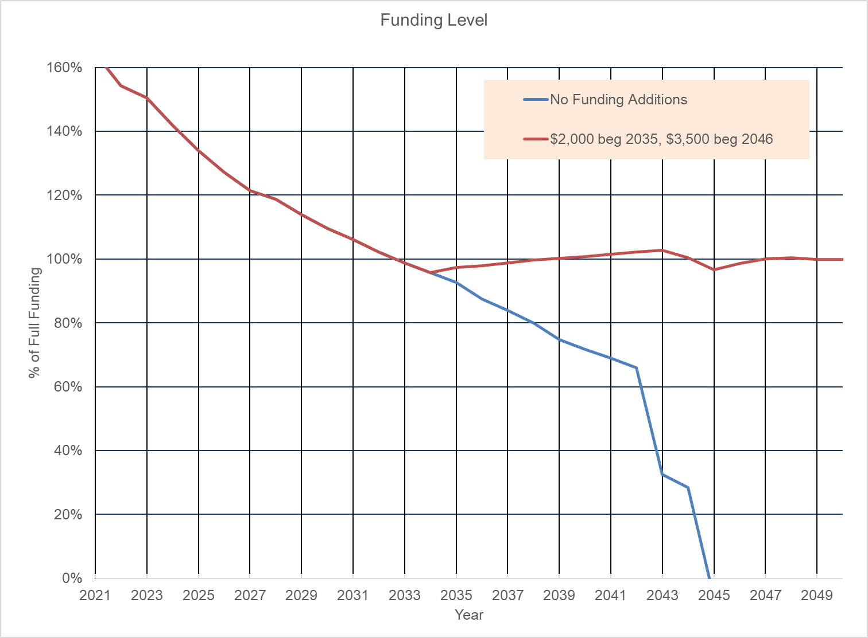
Chart 1 Projected Replacement Reserve Funding Level

Replaceable Assets
Current Year: | 2021 |  | Interest Rate: |  | 2%
Asset | Purchased Year | Useful Life (Yrs) | Remaining Life | 2021 Replacement Cost | Replacement Year | Replacement Cost
Stone Base for SBV sign | 1985 | 50 | 14 | 5000 | 2035 | 6597
Stone Base for SBV sign | 1994 | 50 | 23 | 5000 | 2044 | 7884
Stone Base for SBV sign | 1997 | 50 | 26 | 5000 | 2047 | 8367
Bulletin Board | 2015 | 20 | 14 | 400 | 2035 | 528
Bulletin Board | 2015 | 20 | 14 | 400 | 2035 | 528
Bulletin Board | 2015 | 20 | 14 | 400 | 2035 | 528
Bulletin Board | 2003 | 20 | 2 | 400 | 2023 | 416
SBV Sign | 2012 | 30 | 21 | 3000 | 2042 | 4547
SBV Sign | 2012 | 30 | 21 | 3000 | 2042 | 4547
SBV Sign | 2012 | 30 | 21 | 3000 | 2042 | 4547
SBV Sign | 2012 | 30 | 21 | 3000 | 2042 | 4547
Turtle Creek Sign | 2012 | 30 | 21 | 3000 | 2042 | 4547
Turtle Creek Park Sign | 2014 | 30 | 23 | 1500 | 2044 | 2365
Color Printer¹ | 2017 | 10 | 6 | 3000 | 2027 | 3378
Computer System | 2020 | 7 | 7 | 679 | 2027 | 780
Curb Painting: Address | 2014 | 8 | 1 | 3000 | 2022 | 3060

